**Software Solution for Student House**

**AUTHORS OF THE PROJECT:**

ANDREI ALEXANDRU

RADU POPESCU

BOGDAN CALINESCU

Contents

Contents

**Introduction** 2

**Background** 2

**Problem Statement** 2

**Process & Results** 3

**Results** 5

**Conclusion & Recommendations** 12

**Conclusion** 12

**Recommendations** 12

**Evaluation & Reflection** 12

**Andrei** 12

**Radu** 13

**Bogdan** 14

## **Introduction**

We have successfully finished our first semester’s orientation phase, in which we were introduced to the basics of programming applications in C#, designing interfaces, and other ICT-related subjects. In the past weeks, we can honestly say that we have improved a great deal of our technical knowledge, mostly in the area of Object-Oriented Programming.

This report is meant to present the results on our latest project, named Student Housing BV. We hope that by presenting our work, you can conclude how far we have gotten with our technical knowledge of building robust applications, and we hope you enjoy it in the meantime as well, as we did while building it. To accomplish that, we are going to start by giving you some context about our project.

## **Background**

Student Housing BV is a housing company for students. Each student will share the house/apartment with a couple of roommates and may also share the other facilities, such as toilets, kitchen, and so on, depending on the accommodation building. The only non-shared space is the sleeping rooms, which are given per single student.

As a result of that, we’ve been getting complaints from our clients on multiple topics related to their daily chores, such as shared facilities being dirty, garbage not being taken out, unannounced parties in the house, etc.

With our application, we hope to solve some of the problems in the housing spaces, but for now, let us give you some more details about the issues we are trying to ameliorate.

## **Problem Statement**

The company, Student Housing BV, offers accommodation facilities for students throughout their bachelor’s or master’s studies in the Netherlands. The building consists of personal rooms and shared facilities (kitchen, toilet, bathroom, living room, etc.) on every floor. Through the years, the housing system has faced many problems. Issues are usually related to:

• The capacity of the building usually exceeds 25 people for each floor. That means that everyone must keep clean the shared facilities, but often, due to crowding and non-strict rules, places are found dirty and messy. This happens in the absence of a control system, appointing a specified person on specified assignment for each day and announcing it publicly.

• Meeting with friends at home and organizing parties without informing other floor-mats can be annoying for others. This usually causes spontaneous conflicts between groups of students.

• Tenants are not able to check the updated and agreed rules or announcements.

• Tenants want to contact the administration office easily and inform about technical or personal issues.

• Tenants also need a platform where they can share their complaints or opinions anonymously with others.

## **Process & Results**

**Process**

For our application we have decided to implement the following features:

• Turn-based system for cleaning the shared facilities

We have a page dedicated to chores in our application with tabs for every chore, where the students can go on the tab of the cleaning chore and click the button finished cleaning, or report to the admin that a student did not complete his task.

• Turn-based system for basic expenses and separate tab for groceries.

We have split the grocery system into basic expenses and additional expenses. For the basic expenses each tenant will play a part in making sure the house always has the necessary products. The additional expenses page will create bills for each grocery payment done outside of the basic ones, splitting them among the involved students.

•Turn-based system with punishing consequences

We have a page dedicated to chores in our application with tabs for every chore, where the students can go on the tab of the garbage disposal chore and click the button if they finished taking out the trash, or report to the admin that a student did not complete this task.

•Scheduler for events

The user has multiple options when planning an event. For example, you can select a specific date, you can create an event on the current day, you can request to have no events throughout particular week or remove an event you planned.

We tried to work out a solution for all of the issues listed above with our software, and we believe that it will help solve the problems of the company.

For task management we have decided to use Trello, a popular project management app. As you may see in the picture below every member of the team has individual and pair tasks, this was done in order to reach approximately 10 tasks per team member so that we all get a solid chance to develop and prove the skills we have learned so far.

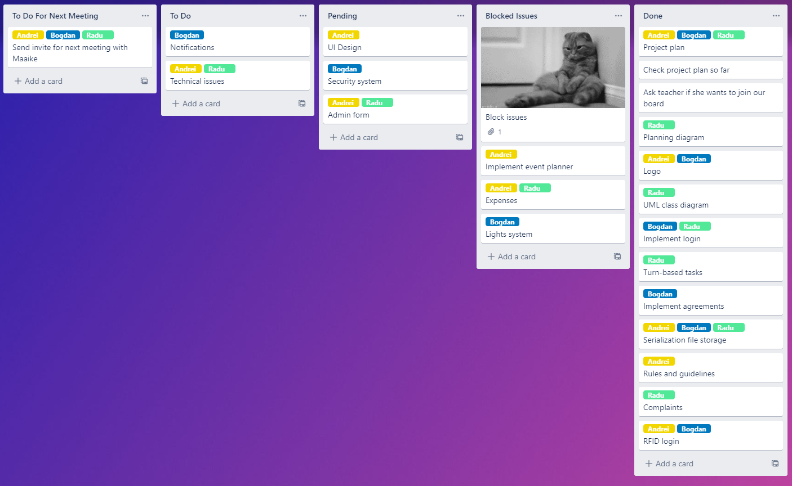

Photo taken of the Trello page towards the end of the project.

Why was our collaboration so smooth?

We had very good communication between us, not only during the university hours, but also in our spare time. We used a variety of platforms to keep in touch about the project, such as Trello, WhatsApp and Discord. We had many group meetings in which we either discussed problems that we faced during the process or we just worked together on the application.

This project provided an opportunity to strengthen our bond as classmates, but also, towards the end, as friends. This was a major advantage, since there were little to no altercations between us, thus, allowing us to focus more on the project rather than improving our work relationship.

Our coding skills were also rather advanced, which helped us to have a smooth workflow with small hiccups. We managed to solve the encountered issues quickly due to our combined skill or because we asked the teacher for help or feedback in advance. Our understanding of the class lectures also helped us in developing the app faster and better.

We also had a good plan designed for this project that we created at the beginning. Our work tasks were divided equally and based on each one’s strength. We also updated the application weekly and merged our solutions using Git.

### **Results**

In this section, a brief explanation of the functionalities of the app will be given which is divided into two sections namely functionalities for the admin and for the students.

#### **App Functionalities for students:**

LOGIN page [1] On this page a person can log in either as a student or as an admin. The admin also has the possibility to log in using an RFID tag.

RULES AND GUIDELINES page [2] On this page the tenants can clearly see the rules and guidelines the company enforced in each of their house or building.

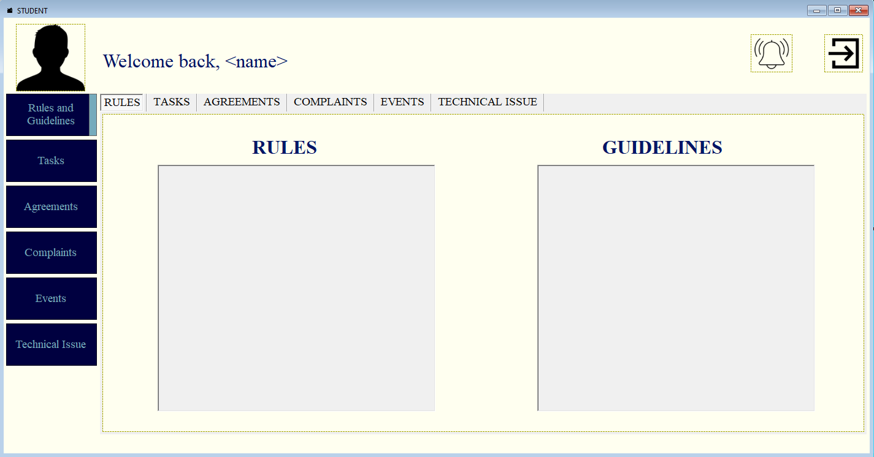

CLEANING page [3] This page handles the cleaning itinerary and helps students with organizing which person is on turn to clean. Also, there is the possibility to log cleaning for someone else.

EXPENSES page [4] In this tab the user can choose between informing the other users that he bought his share of the basic expenses or create a new grocery bill with other users.

TRASH page [5] This page shows who must throw out the garbage. Additionally, someone else can throw the garbage on behalf of the person responsible for throwing the trash.

AGREEMENTS page [6] On this page students can make an agreement with a selected user edit. When an agreement is proposed with a selected user the selected user can accept/reject these agreements, the agreements can also be deleted or edited by the user who made them

COMPLAINTS page [7] The complaint page allows the tenants to transmit the issues they encountered in the student house to the admin/student.

EVENTS page [7] The user can create an event, thus informing the other tenants of said event. They can also state that they do not want an event that particularly week.

TECHNICAL ISSUES page [8] All tenants can send to the administration a small message concerning a technical issue that they have encountered. In the left box will appear the visits that the admin has scheduled based on users reports.

#### **App Functionalities for admin:**

USER MANAGER page [1] Here the admin has the possibility to create, review, update and delete users.

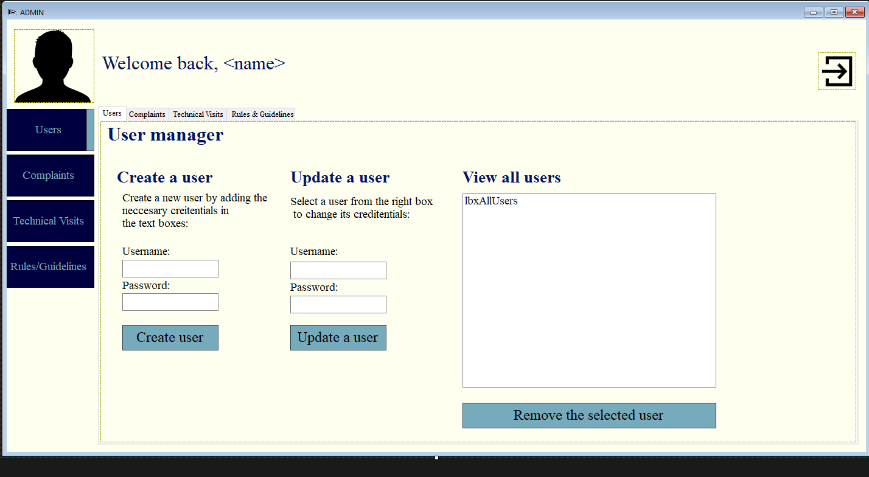

COMPLAINTS Page [2] On this page the admin can see the complaints and the users that got the complaints. Then, he can send warnings to said users.

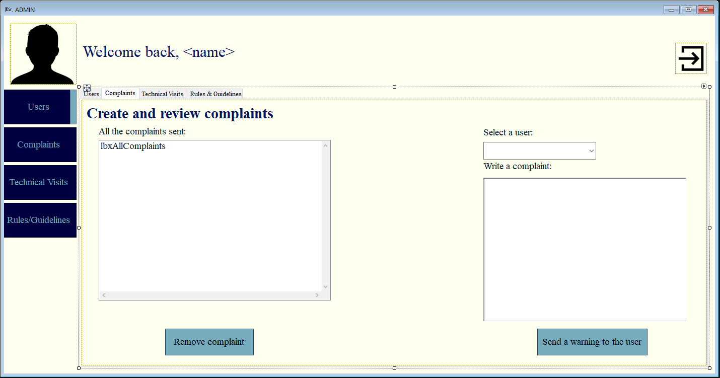

TECHNICAL VISITS page [3] In this tab the admin reviews the reports that the users sent regarding technical issues and can schedule and inform the tenants of the next technical visit.

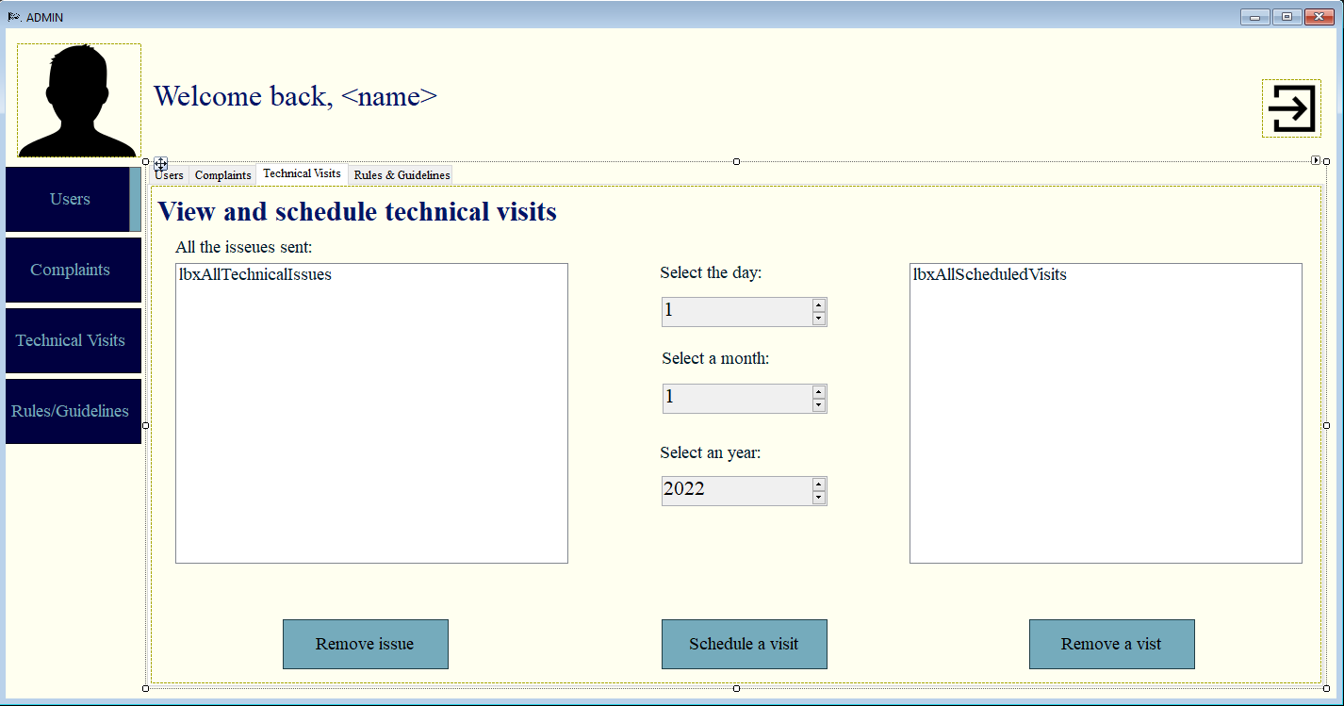

RULES & GUIDELINES page [4] Here the admin can change the rules or guidelines as he pleases, also updating them for the tenants.

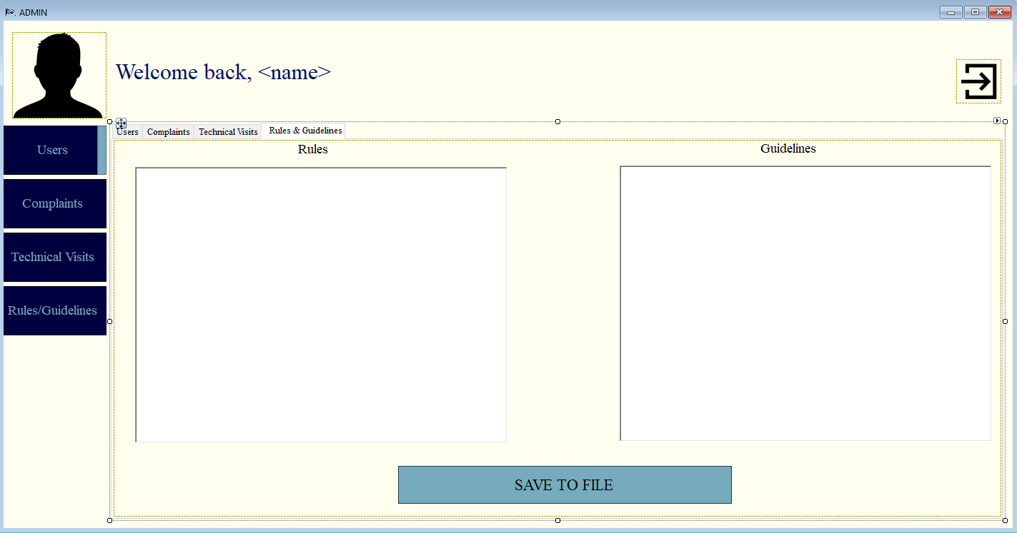

## **Conclusion & Recommendations**

### **Conclusion**

At this point of the project, we have completely delivered all the requirements for the project with the expected functions presented in the interim presentation.

Although the program we have designed is complete and meets all the requirements to solve the issues. Some feedback from the end users might help us improve our solution. Moreover, the program needs to store all the data in a database for better query and retrieving user information.

### **Recommendations**

As an improvement for the application, we can make use of a database system to store and query data from the users. We, however, still need more programming knowledge and practice to realise this goal. A database would be more effective and more practical with the data.

## **Evaluation & Reflection**

### **Andrei**

As a team leader, my contribution to this project is focused primarily on the creation of our app’s design (interface and logo), rules and guidelines feature, event planner system and the expenses management feature as well as helping my teammates with the other features.

Through the process of compiling this advanced project with my team I have realized how much my technical skills improved since the end of last semester. I have applied the concepts learned so far thoroughly so that I make use of everything I was taught during the courses in our solution. I have encountered little to no issues when working on this project. The ones that I have encountered were quickly solved with vast research on the topic or by asking a teacher for help. The materials provided in the courses and by the teachers proved out to be extremely useful and significant for this project’s development as well. I was already familiar with Object Oriented Programming in C#, and this also helped me have a smoother workflow during the coding phase of the project.

I can also proudly state that my team’s atmosphere was amazing. The particularly good collaboration and communication were our key tools towards a very good result from both the technical and professional point of view. Although we sometimes had different visions on what the project should look like in the end, we always managed to come up with a solution to solve these situations and there were no conflicts between any of us. When a member encountered difficulties there was always someone to step in and help, which is a sign of good team chemistry.

Not everything went great though. What I could have done better was how I managed to overload the amount of work I plan for the day. This caused frustration and had effects on how I respected the planning of the Gant chart. Although this behaviour was not intentional, I tried to correct this attitude throughout these “project weeks,” and I have a good end result of my personal effort. I also came to realize that I tend to spend quite some of my time on other projects, such as the individual assignments or personal assignments derived from curiosity. This was helpful in order for me to feel fully prepared when working on the group project. This is one of the reasons that I had little to no trouble when coding on this project. This process also put a lot of stress on my mind due to the closing deadline or the possibility of falling behind the planned schedule with my team.

### **Radu**

During the process of making this application I have developed a lot of skills, both technical and professional. My part in this project was creating and coding the user classes, the technical issues and complaints pages, part of the design and the turn-based tasks.

I have encountered little to no problems when coding and the ones that I had I managed to quickly solve with extensive research on the issue or by asking in advance the teachers for help. The material provided in the lectures proved very useful and meaningful for this project as well. I was already familiar with OOP in C# and this also helped the process have a smoother workflow. Research on various topics related to programming is one of the things I enjoy, therefore I had a lot of extra material I could access during the making of this application.

I can also proudly say that my team-members were fantastic and we had a very good collaboration and communication. We had small hiccups, where we disagreed on some functionalities or simply had different visions about the end-goal of the project, but we always managed to come to an agreement and there were no fights between any of us. When one of us encountered difficulties there were always someone to step in and help, which in my opinion is a sign of a good team.

But not everything worked so smooth. What went rather bad in my case was how I managed to procrastinate and leave the majority of the work for the last days. Although this procrastination is not intentional, I tried to correct this attitude of mine throughout these weeks. I have realised that I tend to spend a lot of my time on research and other project, such as the individual assignments or practicals, so I could be fully prepared when working on the group project. This is one of the reasons that I had little to no trouble when coding for it, but this process also put a lot of stress on my mind due to the closing deadline or the possibility of falling behind schedule.

In the future I will try to correct this attitude by focusing on more important aspects, but not by overlooking the less demanding aspects, rather by alternating between them. I could also improve my schedule with a more concrete work timetable.

By the end of this project, I have realised that I have massively improved how I write C# and how I code in general. I am now more careful when I create classes, what the relation between them is created and how clean the code looks. My communication with others and my integration in the group also improved due to this project but also because of my colleagues.

I am very happy with my team-mates and how the application turned out, we had a very mature approach to this whole project and I look forward to see how the next assignment might look.

### **Bogdan**

As a team member, my contribution to this project is mainly in the creation of the Agreements functionalities, log out feature, notification system and the RFID login as admin.

Working on this project was a new experience for me, where I got to practice hands-on the concepts of OOP by writing a C# application. I strongly believe that the practical part of the course had played a major role in fixing the knowledge that we gathered during the lectures and the self-studies. We also improved our knowledge by encountering some practical challenges that we could not do during the theory classes. Coding in the same project as my team colleagues also made me realize that the final code design of the application depends on the level of communication between the team members.

Considering our challenges to create our very first Advance group project, I’m quite satisfied with how our project ended up to function. We managed to add the functionalities we promised, both on the student and on the admin pages. One thing that we decided to drop was to implement the login with a fingerprint reader for the admin, but we run into some issues because the hardware we had was not usable.

Furthermore, I have realised again the importance of teamwork, how we managed together to brainstorm new ideas into the project. Also, after completing the team discussions, the work became much easier because we had assigned a task for each member in the group, and everyone could work individually for a cooperative goal.

After completing this project, I can also say that I improved my approach on how to filter the needs or the requirements of building an application, and I must admit that being a little creative also helped me tackle the challenges of programming.

For the next project, I would focus on keeping my code as simple as possible, so that other colleagues can easily understand it and maybe change it if needed. I also hope we manage to integrate our application with a real database, that would make things more interesting.

Personally I am happy with how my team worked out the assignment and how we collaborate with each other, in a peaceful and professional manner, even though we had a few disagreements.